Pratap Mishra

Career basic

Project ID - SPS_APL_20200007977

STUDENT PERFORMANCE IN EXAMS

(GRADE ANANLISATION)

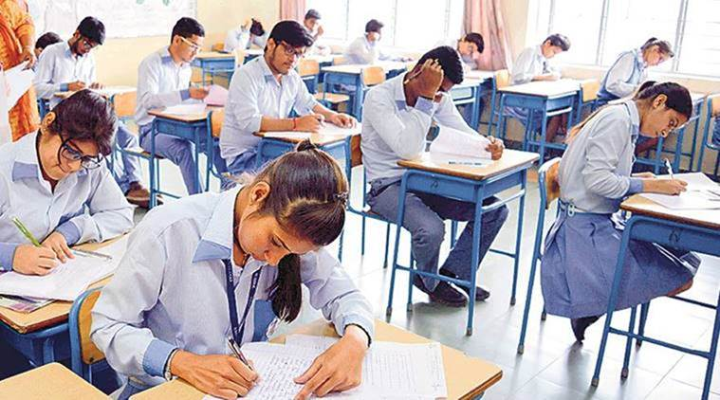

OVERVIEW:

With the wide usage of computers and internet, there has recently been a huge increase in publicly available data that can be analysed. Be it online sales information, website traffic, or user habits, data is generated every day. Such a large amount of data presents both a problem and an opportunity. The problem is that it is difficult for humans to analyse such large data. The opportunity is that this type of data is ideal for computers to process, because it is stored digitally in a well-formatted way, and computers can process data much faster than humans. In schools and higher educational institutes, many students have to struggle hard to pass exams since there is no dedicated support offered to students who need special attention in the relevant courses.  
This thesis examines the application of machine learning algorithms to predict whether a student will be successful or not. Machine learning techniques can be utilized for students’ grades prediction in different courses. Such techniques would help students to improve their performance based on predicted grades and would enable instructors to identify such individuals who might need assistance in the courses. This is best suited for online courses.

GOALS

1)To Evaluate and forecast the performance of the students in exam to give a crucial information and data and let them improve there performance by highlighting there mistakes and improving there overall performance

2)To give vialble data to institutional organisations to understand the flaws in valuation as well as trying to optimise the of the examination and give competent prifessionals in the industries

|  |
| --- |
|  |